Name: Naida Ademović
E-mail: naidadem@yahoo.com
Institution: University of Sarajevo, Faculty of Civil Engineering
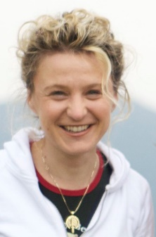 | I was born in Sarajevo, Bosnia and Herzegovina, on 16th February 1973. I obtained my BSc Civ. Eng. in Faculty of Civil Engineering University of Sarajevo (FCE UNSA) in 2001. I obtained my first Master of Science in Computational Engineering at the Ruhr University in Bochum in 2004. In 2011 I completed an Advanced Masters in Structural Analysis of Monuments and Historical Constructions, and obtained my PhD at the FCE UNSA in 2012. Fields of research are: earthquake engineering, bridge and structure design, masonry and concrete structures, life cycle assessment, interaction of earthquake and scour. Author and co-author of over 70 papers/articles at international conferences and scientific journals, and author/coauthor of three books. I have worked on more than 50 professional and scientific projects. I am a reviewer in more than 10 international journals and member of their editorial or scientific board. I have been working in the field of education for 16 years, currently as Associate professor.
This project has been funded with support from the European Commission. This publication reflects the views only of the author, and the Commission cannot be held responsible for any use which may be made of the information contained therein.

